***Diagram Design on***

***“Cash & Carry”***

***Prepared for:***

**Dr. Taslim Taher Assistant Professor**

**Mridha Md. Nafis Fuad Lecturer**

**Course Number & Name:**

**CSE 3224 - Information & System Design Lab**

***Prepared by:***

**Lab Section: A1**

**Group No: 1**

**BIDYARTHI PAUL ID: 20200104023**

**DIPTA BISWAS ID: 20200104013**

**MD. ABDULLAH WALID RIAZ ID: 20200104014**

**FARIHA TASNIM CHOWDHURY ID: 20200104001**

**ZAKIA SULTANA ID: 20200104005**

***Date: 13.07.2023***



***Ahsanullah University Of Science & Technology***

***Department of Computer Science and Engineering***

Use case diagrams:

**LEVEL-0 USE CASE - Supershop Management System**

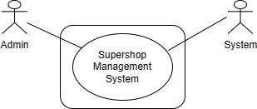

Fig-(1): Level-0 Use case-Supershop Management System

**Description of Use case diagram level-0:**

There are 2 actors who directly or indirectly interact with the system. Primary actors are those who will play action and get a reply from the system whereas secondary actors only produce or consume information. The actors are -

1. Administrator or Owner

2. Customer

**LEVEL-1 USE CASE – Sub system**

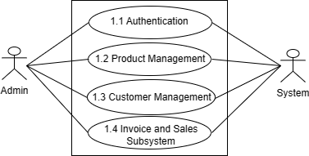

Fig-(2): Level-1 Use case-Sub system

**Description of Use case diagram level-1:**

There are four subsystems in the Super Shop Management System. They are :

1. Authentication

2. Product management

3. Customer management

4. Invoice and Sales Subsystem

The four subsystems are decomposed, in levels 1.1, 1.2, 1.3, and 1.4 respectively.

**LEVEL-1.1 USE CASE - Authentication**

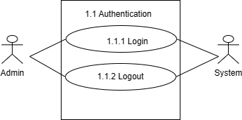

Fig-(3): Level-1.1 Use case-Authentication

**Description of Use case diagram level-1.1:**

When the admin wants to log in, he needs to enter the username and password. If the username and password match, then, the login is successful “Login successful” message is shown. The system shows an error message if the username or password, or both are wrong and the user can try again to log into the system. Admin can log out of the system and can log into the system again.

**Action Reply:**

User (Administrator):

**A1:** User provides username and password

**R1:** System checks validity. If the username and password is valid, the system will allow the user to log into the account.

**A2:** User provides invalid information`

**R2:** The system will show an error message and allow the user to try again.

**A2:** User selects the logout module`

**R2:** The system will be redirected to the login page and the admin will be logged out of the system.

**LEVEL-1.2 USE CASE - Product management**

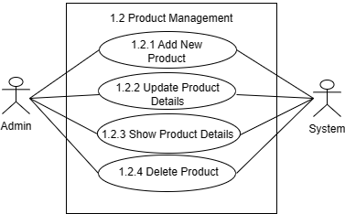

Fig-(4): Level-1.2 Use case-Product management

**Description of Use case diagram level-1.2:**

The Admin can add new products to the inventories, delete and update product details from the inventories as well as can also see the details of all the products present in the inventories.

**Action Reply:**

User (Administrator):

**A1:** User selects add new products, delete products, updates product details options

**R1:** The system acts accordingly and saves the changes.

**A2:** User selects the show details option`

**R2:** The system will show all the details of the available products in the inventories.

**LEVEL-1.3 USE CASE - Customer management**

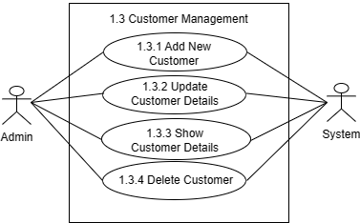

Fig-(5): Level-1.3 Use case-Customer management

**Description of Use case diagram level-1.3:**

The Admin can add new customers to the database, delete and update customer details from the database as well as can also see the details of all the customers from the database.

**Action Reply:**

User (Administrator):

**A1:** User selects add new customers, delete customers, updates customers details options

**R1:** The system acts accordingly and saves the changes.

**A2:** User selects the show details option`

**R2:** The system will show all the details of all the customers from the database.

**LEVEL-1.4 USE CASE - Sales and Invoice management**

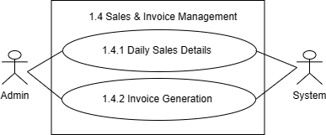

Fig-(6): Level-1.4 Use case-Sales and Invoice management

**Description of Use case diagram level-1.4:**

The Admin can see the details of the daily sales as well as will be able to generate invoices for the customers.

**Action Reply:**

User (Administrator):

**A1:** User selects show Daily sales option

**R1:** The system acts accordingly and shows the details.

**A2:** User selects the invoice generation

**R2:** The system will generate a PDF of the invoice for the customer.

**LEVEL-1.4.2 USE CASE - Invoice generation**

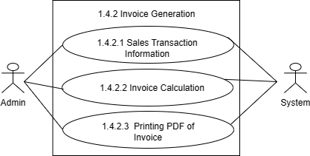

Fig-(7):Level-1.4.2 Use case-Invoice generation

**Description of Use case diagram level-1.4.2:**

The Admin can get the details of the customer and purchased products required for the generation of the invoice. The Calculation of the total price is generated depending on the membership status of the customer. A PDF of the invoice will be generated for the customers.

**Action Reply:**

User (Administrator):

**A1:** User gives input to the necessary attributes to get the sales transaction information (Customer and Purchased product)

**R1:** The system acts accordingly and shows the details.

**A2:** The user sees the membership of the customer and takes an input into the quantities of the purchased products

**R2:** The system will generate a total price according to the membership status.

**A3:** The user saves the invoice after generating all the information after each sale

**R3:** The system will automatically generate a PDF of the invoice for the customer.

**LEVEL-1.4.2.1 USE CASE - Sales transaction information**

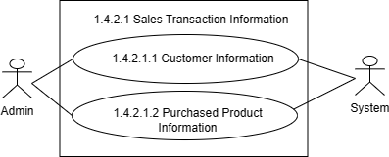

Fig-(8):Level-1.4.2.1 Use case-Sales transaction information

**Description of Use case diagram level-1.4.2.1:**

The Admin can automatically generate all the necessary information in the respective fields using a unique key(phone number). By giving the product name which is the unique key for the product fields, the user can automatically generate all the necessary information for the sales transaction.

**Action Reply:**

User (Administrator):

**A1:** User gives input in the Phone number field

**R1:** The system will automatically give the customer’s information in the respective fields.

**A2:** User gives input in the Product name field

**R2:** The system will automatically give the customer’s information in the respective fields.

**LEVEL-1.4.2.2 USE CASE - Invoice Calculation**

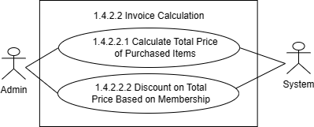

Fig-(9): Level-1.4.2.2 Price calculation and discount application

**Description of Use case diagram level-1.4.2.2:**

The Admin can automatically generate the total price in the invoice according to the membership status of the customer. If the customer has a membership, there will be a 5%

discount in the total price. On the other hand, if the customer doesn’t have a membership, the total price will stay the same.

**Action Reply:**

User (Administrator):

**A1:** The user provides an input where the customer has membership status

**R1:** The system will automatically subtract 5% of the total price from the total price and include the total price in the invoice.

**A2:** The user provides an input where the customer doesn’t have a membership status

**R2:** The system will not provide any discount and the total price will stay the same as before and will include the total price in the invoice.

Swimlane diagrams:

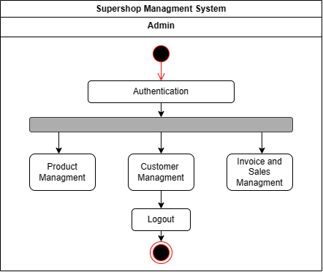

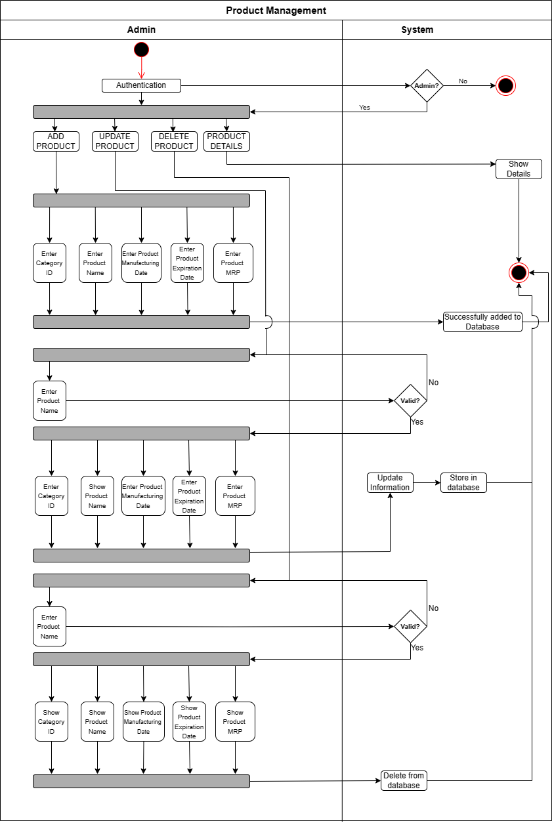

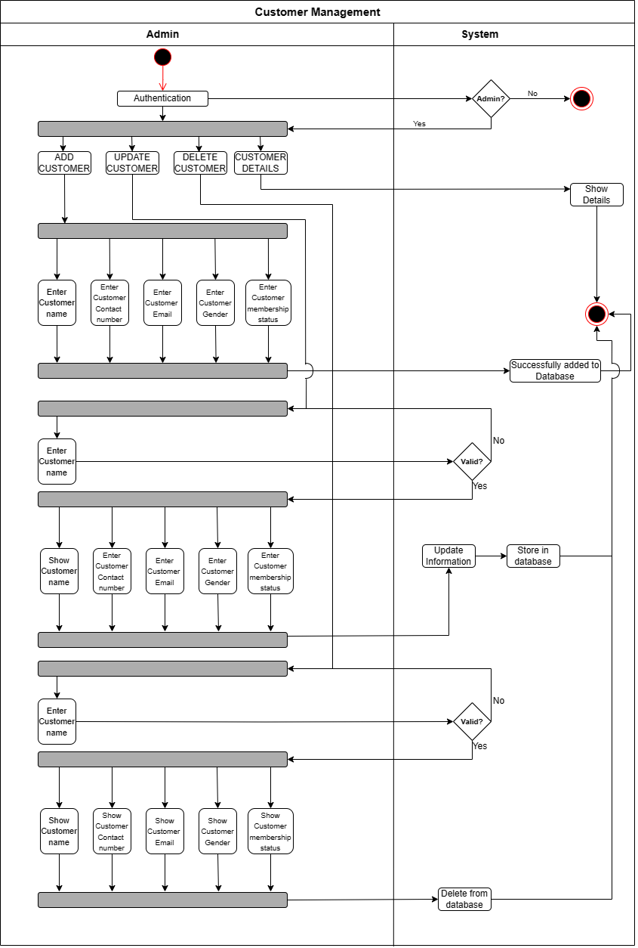

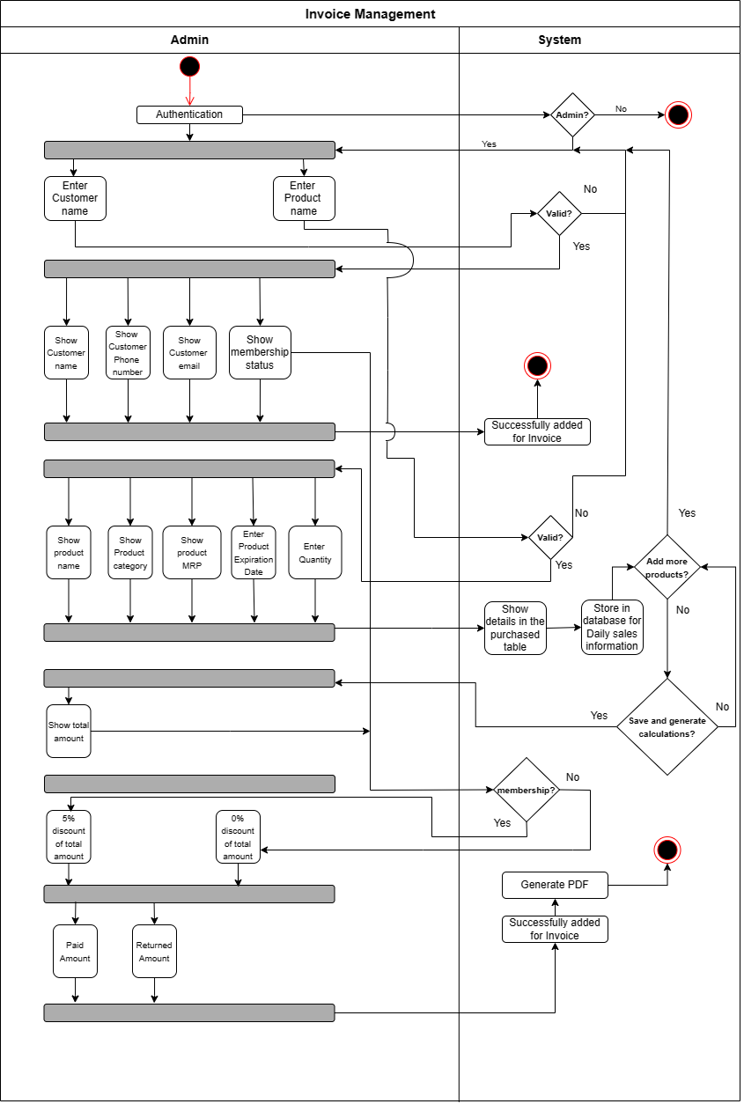

Class diagram:

